RBI-CSF Compliance for Log360
Automate RBI-CSF compliance and fortify cybersecurity resilience for financial institutions with Log360.
Region: India | Type: Financial Services, Cybersecurity Framework, Incident Management | Category: Compliance | Pricing: Free

Overview
The RBI-CSF compliance extension in Log360 helps organizations meet the Reserve Bank of India Cyber Security Framework for Banks (2016), India's mandatory RBI directive requiring scheduled commercial banks to deploy C-SOCs and report cyber incidents within six hours by providing centralized log management, real-time threat detection, data leakage prevention, and audit capabilities. The platform supports RBI-CSF requirements for cyber governance, privileged access management, network security, threat intelligence and incident response, data leakage prevention, SOC surveillance, and audit trail management.
For Cyber Security Governance and Policy Framework, Log360 monitors policy changes, GPO modifications, system events, and Entra ID policy management to ensure governance controls are consistently enforced across banking infrastructure. To address Access Control and Authentication Management, the platform records logon events, failed authentication attempts, and user access activities across Windows, Unix, and Active Directory to enforce access control requirements. The extension also supports Network Security and Perimeter Controls by providing capabilities that monitors network device rules, configuration changes, attack events, policy management, and firewall security reports to maintain and audit perimeter security controls.

Key Features
- Threat Intelligence and Incident Response: Log360 detects threats via Trend Micro, FireEye, and native security reports to support rapid detection and regulatory incident reporting.
- Data Leakage Prevention and Endpoint Security: Log360 monitors file changes, removable media usage, banned cloud applications, registry modifications, and cloud storage activity to detect and prevent data exfiltration across all vectors.
- Security Operations Center Surveillance: Log360 provides continuous threat monitoring, process tracking, event log aggregation, and system event correlation to support round-the-clock SOC surveillance capabilities.
- Audit Trail and Log Management: Log360 collects MFA events, Oracle database security changes, Unix NFS events, system logs, process tracking, and detailed system events for comprehensive audit coverage.


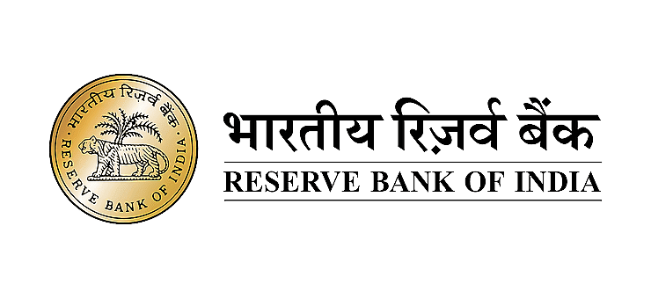

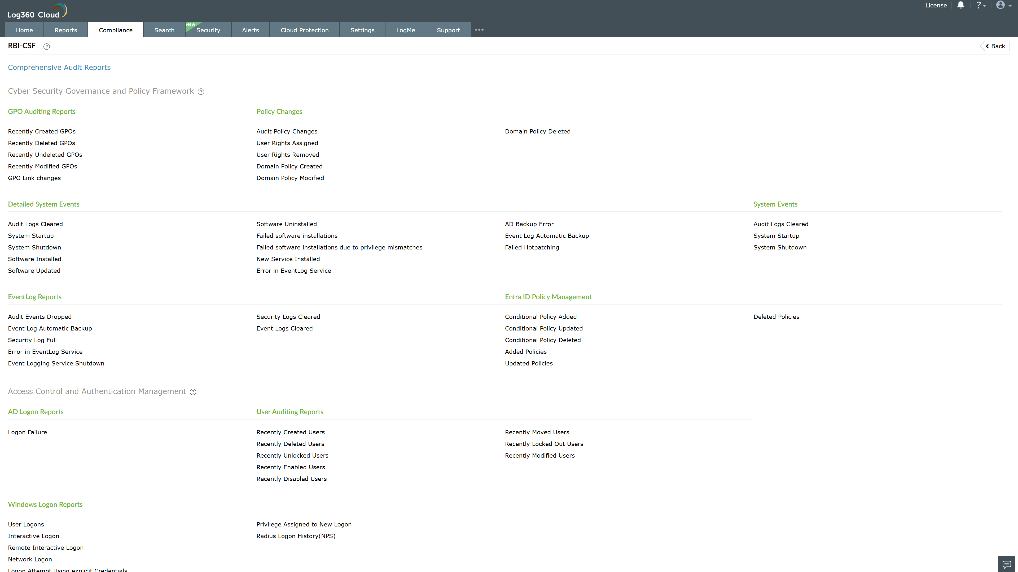
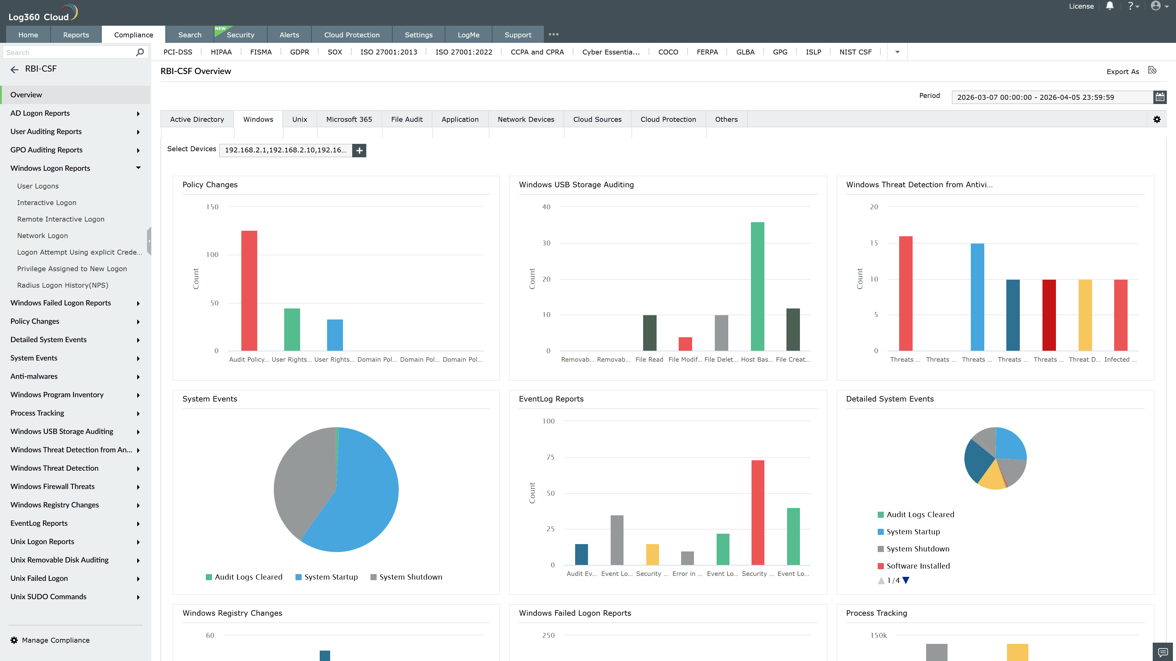
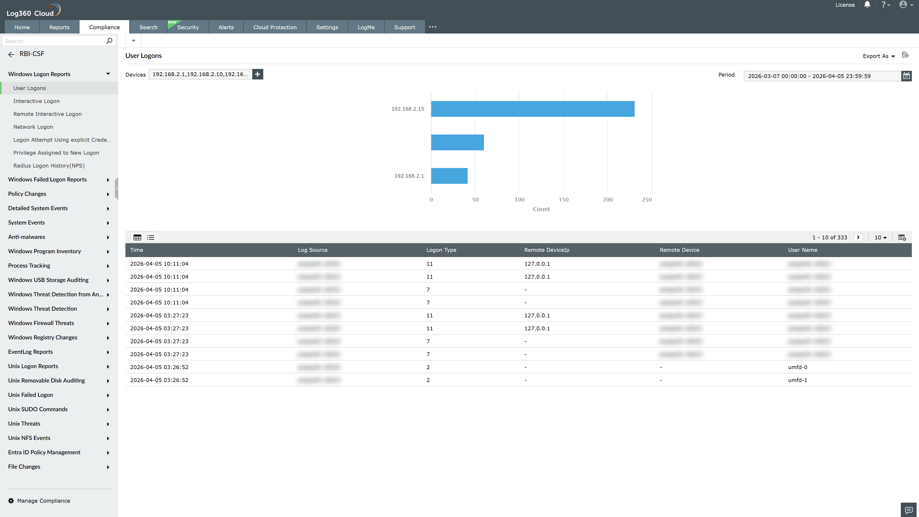
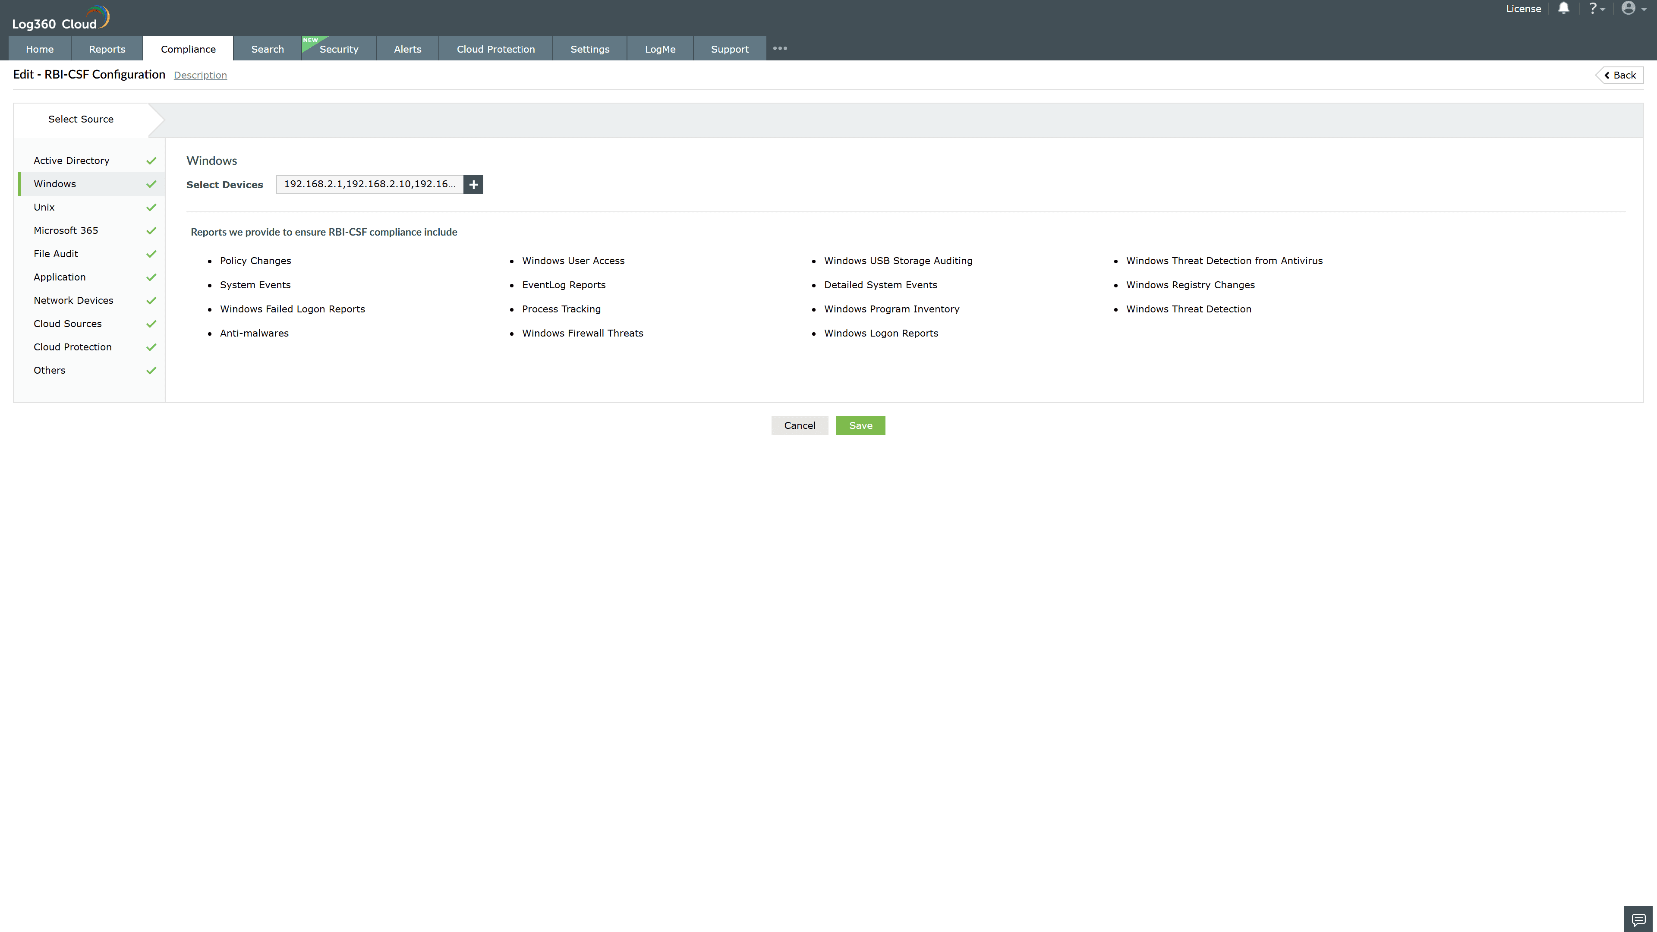
Valid Submission : Yes
Supported Editions : Free, Basic, Standard, Professional, MSSP
Help Document : https://www.manageengine.com/log-management/help/integrations/compliance-extensions.html
Help Video : Not provided
Tags : Log360, Compliance, Privacy monitoring, Data privacy, Regulatory compliance
Supported DCs : US, IN, JP, CA, AU, UK and EU
Privacy Policy:
Terms of Service:
Release Notes:
Predefined reports for the RBI-CSF.

